September 23, 2026

VICE PRESIDENTS, AREA RETAIL AND DELIVERY OPERATIONS
VICE PRESIDENTS, REGIONAL PROCESSING OPERATIONS

SUBJECT: Operations Policy for the Columbus Day Holiday, Monday, October 12, 2026

This memorandum provides general operating policy and holiday planning guidance for the upcoming 2026 Columbus Day Holiday (observed on Monday, October 12, 2026). Service levels for this holiday are displayed in Exhibit 125.22 of the Postal Operations Manual (POM).

Columbus Day is a non-widely observed holiday, which means that many businesses are open and producing outgoing mail.

Delivery Operations

All offices should carefully review their staffing plans for this holiday and adjust as necessary to meet the needs of their communities.

- All delivery units should act prior to this date to ensure that units are in a current package and mail delivery status
- For planning purposes, Post Offices should use recent mail volume trends, and adjust for any unforeseen local circumstances
- The pre- and post-holiday surveys adhering to delivery compliance with these plans must be completed with accuracy and integrity

Tuesday, October 6, 2026:
- Local management should review the Route Book for the following week’s holiday drop times by our same day mailers. Route Books will be sent from the External Customer Integration Team via the SharePoint below and My Post Office (MyPO) certification link:

HQ External Customer Integration (sharepoint.com)

- A delivery manager or supervisor must:
  - Post the holiday work schedules that align with holiday mail delivery commitments
  - Review attendance patterns to be addressed prior to the holiday
  - Ensure compliance with the Triangulation Pull Up Play Escalation leading into the holiday weekend

Saturday, October 10, 2026:
In addition to regular (Saturday) delivery and collections, all delivery offices should:
- Take appropriate action to ensure units remain in a current status; the expectation is to have zero delayed or curtailed mail volumes going into the holiday
- Ensure planning and scheduling with craft and EAS are in alignment to reduce splitting open assignments while addressing efficiencies, eliminating late carriers, service & scanning failures, and minimizing overtime & penalty overtime accumulation
Sunday, October 11, 2026:
- Normal (Sunday) service levels will be provided in delivery operations including Sunday/Holiday Priority Mail Express and Sunday/Holiday Same Day Package Delivery (HUB and spoke structures)
- Management should schedule based on Dynamic Routing (DRT) projections versus actual work hour usage
  - Carriers should not be scheduled prior to 10:00 AM Local Time/Distribution Up Time (DUT)
  - Carriers should be loading their vehicles within 15 minutes of their begin tour
  - Carriers should be delivering packages within 45 minutes of their begin tour
- EAS must be present during morning office and loading operations
- EAS must use Delivery Management Systems (DMS), when available, to confirm proper scanning and delivery of Sunday parcels has been completed at all locations
- Delivery of any product not committed (including delayed mail delivery) on this day will only be approved by the Vice President for that assigned Region with prior notification provided to the Chief Retail & Delivery Officer
Columbus Day Holiday, “Non-Widely Observed”, Monday, October 12, 2026:
- Delivery of any product not committed (including delayed mail delivery) on this day will only be approved by the Vice President for that assigned Region with prior notification provided to the Chief Retail & Delivery Officer
- There will be no regular delivery service except for Holiday Premium Priority Mail Express and Holiday Same Day Package Delivery (HUB and spoke structures)
- There will be Amazon Night Owl drops scheduled Sunday night into Monday for holiday delivery.
- Please review the Amazon Route Book for the holiday drop times
- EAS must use DMS, when available, to confirm proper scanning and delivery of Holiday Same Day parcels has been completed at all locations

Tuesday, October 13, 2026:
Return to normal service levels.

- Ensure planning and scheduling with craft and EAS are in alignment to reduce splitting open assignments while addressing efficiencies, eliminating late carriers, service & scanning failures, and minimizing overtime & penalty overtime accumulation without conducting 6 to 9 package delivery or pre-touring carriers
- Take appropriate action to ensure units remain in a current status; the goal is to have zero delayed or curtailed mail volumes
- Review past performance and work with In-Plant Support and Network Operations on transportation
- Full local management engagement, to include reducing and eliminating telecoms during morning operations, to support the front-line delivery teams
- Collections must start and run-on time to meet the DOV to the mail processing facilities
- Review of routes after a holiday – All Senior Management (EAS 23 and above) shall conduct a 3999-route review. A selection of routes will be provided by HQ Delivery prior to the Holiday.

Retail and Post Office Operations

Management should review staffing plans and adjust as necessary to meet the needs of their communities using recent and same period as last year (SPLY) retail sales trend information and mail volumes.

Management should ensure SSK, Rapid Dropoff Station (RDS), and Smart Locker consumables and supplies are fully stocked and postage stamps/mailing supplies (Expedited Packaging Supplies, ReadyPost, Greeting Cards, Gift Cards) are available for customers.

Offices should display proper “door cling” signage prior to the holiday. Visibly taped or handwritten signage is not acceptable. Advise customers of any Contract Postal Units (CPUs) or Approved Shipper (APS) locations where retail services will be available on the Columbus Day holiday and provide them with the hours of operation.

Offices should ensure their facilities are cleaned and maintain their daily PS Form 4852/Line H requirements for custodial operations.

Saturday, October 10: Normal (Saturday) service levels will be provided in Retail and Post Office Operations.

- Remote Forwarding System (RFS): Ensure undeliverable parcels are processed timely to avoid backlogs through the holiday.
- Parcel Return Service (PRS): Dispatch PRS as scheduled. If needed, escalate non-picked up package issues to your Business Service Network (BSN) representative, and annotate in RADAR. For Return Delivery Units (RDU), follow the 48-hour rule before dispatching to the plant.
- Equipment: Confirm all scanning equipment is operable and transmitting without incidents including: ADUS, SDUS, PASS, DSS, MDD-IO. Extra batteries should be kept on hand as needed. For ADUS and SDUS equipment, the holiday sort plan mimics the Sunday PDTAT configuration. Sites should verify their PDTAT files are correct. If changes are required, submit RADAR Sort Plan Change Request link by Thursday, October 8.
- Notice Left Shelf: Verify items receive notification or are returned according to the schedule. For post office box packages, if it fits, place in the PO box or parcel locker.
- Smart Locker Deliveries: Continue depositing eligible packages into Smart Lockers whenever possible. Monitor locker capacity and clear expired packages to maximize compartment availability for customers during the holiday weekend.
- MyPO Notifications: Check MyPO notifications, including hold mail, package pickups and redelivery. Ensure items are closed in MyPO timely. Carrier pickup requests are to be closed the same day as the request in MyPO, otherwise they will be reported as failed.
- ‘First In First Out’ (FIFO): Use placards, signs, and lines for maintaining FIFO to manage volume and assist with applying the correct Delivery Day Indicator (DDI).
- Delivery Day Indicator (DDI): Management oversight to ensure delivery units apply the correct DDI BEFORE scanning packages (see below). REMINDER: After 11:00 AM, when there has been 15 minutes with no scans (idle time), “Today” will no longer display as a DDI option. The “Tomorrow” DDI option will not display until after 8:00 AM on PASS, DSS, and MDD-IO. Exception: On Sundays and Holidays, the “Tomorrow” option is available starting at 12:00 AM (midnight).
- PM Parcel Distribution: Review volumes, schedules, and work all available parcels in the PM to ensure unit is clean before the holiday.
- ADUS and SDUS sites should prep and stage any on hand PM parcel volume for early ADUS/SDUS runs on the day after the holiday.
- Sorting and Staging Area: Confirm all processing equipment/containers are neat, in place, and ready for the following day. Check housekeeping: floors clear of debris, trash bins emptied, extra empty equipment staged ready for pickup.
- Verify the Amazon route book for scheduled drop times over the holiday weekend.
- Utilize the Amazon projections sent on Tuesday (10/6/26) for proper planning and scheduling.
- Confirm users have the correct PDTA access to send for routing.
- Ensure all MTE is prepped and dispatched back to plant partners.
- Ensure all SSK alerts are cleared, and consumables are filled before leaving COB (receipt tape and labels).

DDI Selections:

Date Packages are  SCANNED | Date Packages will be DELIVERED | DDI Selection
Saturday, October 10, 2026 | Sat - October 10 | Today
Saturday, October 10, 2026 | Sun - October 11 | Sunday
Saturday, October 10, 2026 | Mon - October 12 | Holiday
Saturday, October 10, 2026 | Tue - October 13 | Next Day*
Sunday, October 11, 2026 | Sun - October 11 | Sunday
Sunday, October 11, 2026 | Mon - October 12 | Holiday
Sunday, October 11, 2026 | Tue - October 13 | Next Day*
Monday, October 12, 2026 | Mon - October 12 | Holiday
Monday, October 12, 2026 | Tue - October 13 | Next Day*
Tuesday, October 13, 2026 | Tue - October 13 | Today
Tuesday, October 13, 2026 | Wed - October 14 | Tomorrow
* Used for processing packages on the current day, BUT have a Delivery Date for the Next Day

Sunday, October 11: Normal (Sunday) service levels will be provided including Sunday/Holiday Priority Express and Sunday/Holiday Same Day package processing and delivery in Hub/Spoke structure. There will be Amazon Night Owl drops scheduled Saturday night into Sunday morning for Sunday delivery.
- Function 4 Staffing: Balance workhours to workload by reviewing the VAP Gap tool to identify staff opportunities, assess Sunday and holiday volume trend data and mail arrival times to schedule staff that coincides with the workload and performance expectations.
- Collections: At the local level, confirm holiday-specific collection transportation schedules for the dispatching of collection mail. Clear collection points in front of and within the post office (e.g., collection boxes, inside lobby drops and self-service kiosks) prior to truck arriving and dispatch all available outgoing mail on first available truck. Follow separation and MTEL placarding procedures when preparing mail for dispatch according to local holiday schedules Ensure all MTE is prepped and dispatched to plant partners.

Monday, October 12: Columbus Day Holiday, “Non-Widely Observed”:
- Retail services will not be available.
- Post offices should provide post office box access for customers to the maximum extent possible.
- Post Office Operations personnel on duty should check and clear collection points in front of and within the post office (e.g., collection boxes, inside lobby drops and self-service kiosks) follow separation and MTEL placarding procedures to prepare and dispatch all outgoing mail on first available truck.
- District managers or designee will coordinate with plant partners to staff remittance units if warranted. District Integrated Operating Plan Specialists should review District and local surface and air transportation network holiday schedules. If networks are operating, ensure major mailers are contacted to make certain volumes are collected and inducted into the system in a timely manner.
- District Integrated Operating Plan Specialists should work in conjunction with local processing and transportation personnel to ensure IOP agreements are being followed and MAQ/PAQ anomalies are being recorded properly.
- Amazon will drop to all Sunday Amazon HUB sites on Monday for holiday HUB delivery. Please review the route book to be staffed for the scheduled holiday drop time.
- There will be Amazon Night Owl drops scheduled Sunday night into Monday for holiday delivery.
  - “Holiday” configuration must be used as day of week selection in PDTA.
- Ensure all MTE is prepped and dispatched to plant partners if applicable.

Tuesday, October 13:
- Return to normal service levels. Management should review the SSRD from 10/14/25 (FY25 day-after “observed” Columbus Day Holiday) and use recent sales trend information to adjust for local circumstances.
- Check SSK, RDS, and Smart Locker consumables and clear alerts. Review Smart Locker usage and clear expired package. Ensure supplies are fully stocked and postage stamps/mailing supplies (Expedited Packaging Supplies, ReadyPost, Greeting Cards, Gift Cards) are available for customers.
- Package pickup services should be provided at Dutch doors along with soft openings to reduce customer wait times to the fullest extent possible.
- Function 4 Staffing:
- Plan for additional mail volume and packages for post-holiday delivery
- Review VAP Gap tool, post-holiday volume trend data, CSAW projections, mail arrival times and utilize F4 IVES Scheduler to plan for staffing that coincides with the projected workload and performance expectations.
- Ensure all MTE is prepped and dispatched to plant partners.

Processing Operations

This holiday presents an opportunity to consolidate and compress plant operations to generate savings while maintaining service performance levels. In order to take advantage of the savings opportunity, please adhere to the following guidelines:

- There will be NO cancellations on Monday holiday
- RTO volumes will not be cancelled on the Holiday
- Opening Units kept at day zero for Letters and Flats.
- Advance all available blue & orange Marketing Mail for Saturday delivery
- Review IVES scheduling to match operating plans.
- Focus on RPG Compliance and P2P (Start Time & Throughput).
- Inhibit Delivery Point Sequence (DPS) sort program regeneration prior to the holiday and re-establish afterwards.
- Utilize an RPG model for DPS processing on Sunday & Monday night that ensures an early DPS dispatch for Tuesday delivery.
- Ensure only one DPS run on Tuesday morning (no double runs of DPS).
- Communicate with Manager Customer Relations and Logistics to leverage mailer volumes available for Holiday pick up and Outgoing processing.
- Decisions for Tuesday early collection plans will be determined locally by Region/Division. (See below instructions related to processing and dispatching Commercial Mailings).
- Evaluate the processing of Outgoing Packages on the day of the holiday to avoid late clearance on Tuesday. (Sites not processing OG on the holiday must create an early collection plan to start outgoing operations earlier).
- Assign SWYB to avoid VAP issues to THS.

Processing NOCC
- Increased nightly oversight of plant performance to plan/capacity
- 24-hour coverage, including on the holiday, to provide assistance and escalation
- Increased monitoring of MMP performance to plan on Saturday & Sunday
- Increased monitoring of DPS performance to plan on Sunday and Monday
- Monitoring of all planned/unplanned Power Outages

Specific planning activities should include:

- Coordination with Business Mail Entry Unit (BMEU) Managers.
- Coordination with Detached Mail Units
- Coordination with Business Service Network Managers.
- Notifying Commercial Mailers of BMEU Holiday hours and assurance that mail which is entered will be processed and dispatched.
- Adjusting Operating Plans and RPGs to include the anticipated Commercial Mail volumes.
- Ensuring that all processed mail is dispatched on scheduled transportation on Monday night and Tuesday morning.
- Ensure communication to the field of the Air and Surface Network dispatch plans.

Plant managers must ensure that Parcel Return Service (PRS-569xx) operations will be staffed, and all returns sorted and available to PRS partners as agreed.

Plant managers are to ensure proper Priority Mail Open & Distribute (PMOD) process, especially ensuring all destinating volume receives it’s stopped the clock Received at Opening Unit (RAOU) scan upon arrival.
Plant managers must ensure that Integrated Operating Plans (IOPs) between the BMEUs and Operations are updated to ensure timely induction, processing and dispatch of mail presented to the BMEU prior to and on holidays. BMEU managers must ensure that all staff at both the BMEUs and the Detached Mail Units are familiar with and execute their operations in accordance with the IOP. Local collection and cancellation plans must be coordinated with associate offices and must support the achievement of Operating Plan Precision. Managers and supervisors must plan for anticipated increased volumes after the holiday. It is vital to ensure all mail is finalized, prepared for assignment, and dispatched on the appropriate transportation network.

Plants must make plans to ensure that destinating volumes are processed to meet service goals before and after the holiday. All missorted, missent, return-to-sender and Postal Automated Redirection System (PARS) and Flat PARS volumes must be identified, finalized, prepared for assignment and dispatched on the appropriate transportation network on Saturday.

Reductions in FAST holiday constraints or facility closures will not be approved; every site must maintain appointment availability.
Plants need to ensure timely acceptance of drop shipments. Please ensure that the local FAST facility profile contact information is current.
The FAST Help Desk will be authorized to contact local Plant Managers directly to resolve urgent acceptance issues.

If there is a need to deviate from this guidance, please work through the appropriate office for an exception.

This non-widely observed holiday presents an opportunity to maximize processing to take full advantage of available lift and ensure service expectations are met. Please adhere to the following guidelines:

- All ISCs should work with domestic partner sites to ensure all Export mail is captured prior to holiday and all Import mail is processed or transported to the domestic site for service commitment
- Ensure coordination with Customs & Border Protection (CBP) to provide sufficient staffing to avoid backlogs
- Ensure Customs belts are staffed sufficiently to maximize efficiency and stop the clock events are performed as required
- Ensure processing and dispatch of all mail throughout the holiday weekend to avoid exceeding or missing surface or air transportation

International Service Center Operations

This non-widely observed holiday presents an opportunity to maximize processing to take full advantage of available lift and ensure service expectations are met. Please adhere to the following guidelines:

- All ISCs should work with domestic partner sites to ensure all Export mail is captured prior to holiday and all Import mail is processed or transported to the domestic site for service commitment
- Delayed volumes should be worked in advance
- Ensure coordination with Customs & Border Protection (CBP) to provide sufficient staffing to avoid backlogs
- Ensure Customs belts are staffed sufficiently to maximize efficiency and Stop the clock events are performed as required
- Expedite Import Express to the FEDEX network to avoid lift issues
- Ensure on-time clearance of Priority and FC SPRs to avoid surface volume rolling over
- Ensure processing and dispatch of all mail throughout the holiday weekend to avoid exceeding or missing surface or air transportation

Maintenance Operations

The Maintenance Technical Support Center (MTSC) will assist mail processing sites with planned power outages in accordance with the following knowledge base (KB) article.
Facility Planned Power Outages
MTSC KB0012715

Refer to the Mail Processing Emergency Response Checklists for critical actions and tasks.

Additional Information

- For all power outages, create a ticket on the MTSC Web Ticket Portal for the affected site and provide all relevant information about the outage.
- For planned power outages, sites must submit a Change Request (CR) form to FAP_Power_Outage_Notification@usps.gov. The CR form is available in the MTSC KB.

Upon receipt of the MTSC web ticket, the MTSC Network Operations Application Support (NOAS) team will contact Engineering to:

- Schedule graceful shutdowns of IDS, NDSS, and NGTC for planned outages.
- Validate functionality after power is restored for all outages.

If a system has issues going online after power is restored, then create a new ticket for the affected system and request NST assistance.

Non-Emergency Project Requests

MTSC will provide phone support 24 hours a day through the holiday but will curtail all
non-emergency support activities to ensure sufficient HelpDesk coverage during the holiday scheduling period. Normal projects and supplemental support activities will resume in the week following the holiday.

Logistics Operations

Air Transportation Network

UPS:
UPS will have normal Tuesday operations during the Columbus Day period.

Holiday | Day of Week |  | Date | Postal Volume Tendered | Comments
Day before |  | Sunday | 10/11/2026 | YES | Normal Tender
Columbus Day |  | Monday | 10/12/2026 | NO | No Mail Tender
Day after |  | Tuesday | 10/13/2026 | YES | Normal Tender
 |  | Wednesday | 10/14/2026 | YES | Normal Tender

FedEx:
Normal FedEx Nightsort operations are planned during the Columbus Day period.

Holiday | Day of Week | Date | Night (x67) | Comments
Day before | Sunday | 10/11/2026 | NO
Columbus Day | Monday | 10/12/2026 | YES | Normal Tender
Day after | Tuesday | 10/13/2026 | YES | Normal Tender
 | Wednesday | 10/14/2026 | YES | Normal Tender

CAIR:

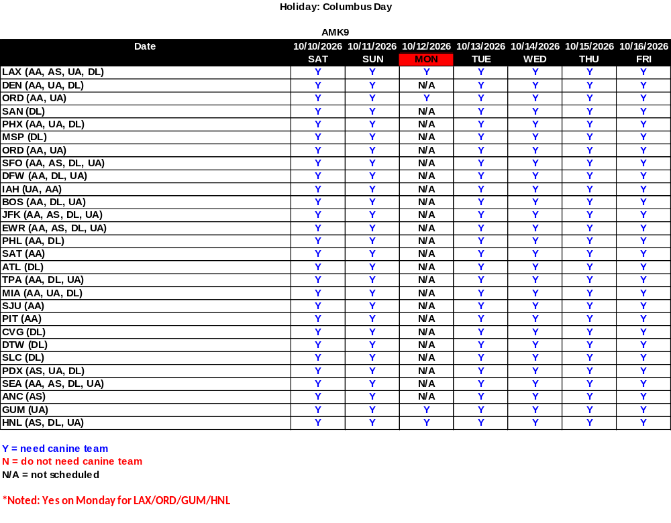

International Transportation Plan

Import/Export Plan for the ISC
Holiday | Day of | Date | JFK | JFK | ORD | ORD
Holiday | Week | Date | Export | Import | Export | Import
Day before | Sunday | 10/11/2026 | YES | YES | YES | YES
Columbus Day | Monday | 10/12/2026 | YES | YES | YES | YES
Day after | Tuesday | 10/13/2026 | YES | YES | YES | YES
Holiday | Day of | Date | LAX | LAX | MIA | MIA
Holiday | Week | Date | Export | Import | Export | Import
Day before | Sunday | 10/11/2026 | YES | YES | YES | YES
Columbus Day | Monday | 10/12/2026 | YES | YES | YES | YES
Day after | Tuesday | 10/13/2026 | YES | YES | YES | YES
Customs CBP opening plan and hours at the ISC
Holiday | Day of | Date | JFK | JFK | ORD | ORD
Holiday | Week | Date | CBP open | CBP hours | CBP open | CBP hours
Day before | Sunday | 10/11/2026 | YES | 24/7 | YES | 06:00 – 15:00
Columbus Day | Monday | 10/12/2026 | YES | 24/7 | YES | 06:00 – 15:00
Day after | Tuesday | 10/13/2026 | YES | 24/7 | YES | 06:00 – 15:00
Holiday | Day of | Date | LAX | LAX | MIA | MIA
Holiday | Week | Date | CBP open | CBP hours | CBP open | CBP hours
Day before | Sunday | 10/11/2026 | YES | 06:00 – 14:00 | YES | 06:00 - 14:00
Columbus Day | Monday | 10/12/2026 | YES | 06:00 - 21:00 | YES | 06:00 - 16:00
Day after | Tuesday | 10/13/2026 | YES | 06:00 - 21:00 | YES | 06:00 - 20:00

Dispatch Procedures

To avoid transportation delays, manage mail volume flow before, during, and after the holiday accordingly:

- Maximize utilization of available surface, commercial air, and UPS transportation during the holiday period. Dispatch all mail volume inducted on Sunday and Monday nights into the network on Tuesday to avoid overflow on Wednesday’s network.

- Prioritization values established for planned routes will ensure commercial air capacity is utilized ahead of UPS.

Please disseminate these policies and procedures to the appropriate personnel in your area.
Your immediate attention to these details and dispatch procedures is appreciated.

Thank you for your assistance.

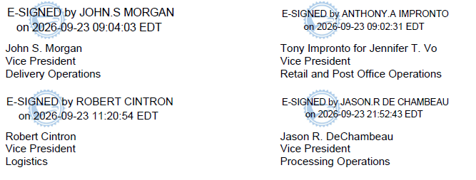

cc: Mr. Mercado.
Mr. Cronkhite

