

December 3, 2024

VICE PRESIDENTS, AREA RETAIL AND DELIVERY OPERATIONS

VICE PRESIDENTS, REGIONAL PROCESSING OPERATIONS

SUBJECT: **Operations Policy for the Christmas Holiday, Wednesday, December 25, 2024**

**and the New Year’s Day Holiday, Wednesday, January 1, 2025**

This memorandum provides general operating policy and holiday planning guidance for the upcoming 2024 Christmas holiday and the 2025 New Year’s holiday (observed on Wednesday, December 25, 2024 and Wednesday, January 1, 2025, respectively).

Service levels for these holidays are displayed in Sections 125.22 and 313.24 of the *Postal Operations Manual* (POM). This memorandum also contains guidance for notifying the public of changes in service levels on Christmas Eve and New Year’s Eve.

**All delivery units remain decoupled through December 28, 2024.** Continuing through the end of Peak, we are conducting 6:00am to 9:00am Morning Package Plays only in ***Peak Identified Delivery Units***. Package Plays assist delivery offices in maintaining on-time service and eliminate potential delayed and curtailed mail volumes. These plays are designed to adjust for volume and staffing when volume projections exceed daily capacity.

**Delivery Operations**

All offices should carefully review their staffing plans for these holidays and adjust as necessary to meet the needs of their communities.

* All delivery units should act prior to the “*eves*” to ensure units are in a current package and mail delivery status.
* For planning purposes, Post Offices should use recent mail volume trends, and adjust for any unforeseen local circumstances.
* The pre- and post-holiday surveys adhering to delivery compliance to these plans must be completed with accuracy and integrity.

**Tuesday, December 17, 2024:**

* Local management should review the Route Book for the following week’s holiday drop times by our same day mailers. Route Books will be sent from the External Customer Integration Team via the SharePoint below and My Post Office (MyPO) certification link:

[**HQ External Customer Integration (sharepoint.com)**](https://gcc02.safelinks.protection.outlook.com/?url=https%3A%2F%2Fusps365.sharepoint.com%2Fsites%2FHQExternalCustomerIntegration&data=05%7C01%7CChandria.Z.Perry%40usps.gov%7Ccd630ccd7a934d2d7e4908da876c3ccc%7Cf9aa5788eb334a498ad076101910cac3%7C0%7C0%7C637971196183262241%7CUnknown%7CTWFpbGZsb3d8eyJWIjoiMC4wLjAwMDAiLCJQIjoiV2luMzIiLCJBTiI6Ik1haWwiLCJXVCI6Mn0%3D%7C3000%7C%7C%7C&sdata=%2B%2FsIvFqIxXDVoNMg5yOMHULx%2F7uCZVSzL%2Fr5XHxZUOo%3D&reserved=0)

* A delivery manager or supervisor must:
  + Post the Christmas holiday work schedules and review attendance patterns to be addressed prior to the holiday.
  + Ensure compliance to the Triangulation Pull Up Play Escalation leading into the holiday.

**Tuesday, December 24, 2024:**

In addition to regular delivery and collections operations, all delivery offices should:

* Take appropriate action to ensure units remain in a current status; the goal is to have zero delayed or curtailed mail volumes going into this holiday.
* Plan and schedule in alignment to address efficiencies to ensure overtime impacts are reduced.
* Conduct the necessary Morning Package Plays only in ***Peak Identified Delivery Units*** to eliminate potential delays and minimize late returns.
  + Deliver a minimum of 15% of **ALL** packages between 6:00am and 9:00am.
* Conduct Evening Package Plays only in ***Peak Identified Delivery Units*** to become current, if necessary.
* There will be no Amazon Night Owl drops on December 24th, for Wednesday/holiday delivery.
* Local management should review the Route Book for the following week’s holiday drop times by our same day mailers. Review Route Books sent from the External Customer Integration Team via the SharePoint below and My Post Office (MyPO) certification link:

[**HQ External Customer Integration (sharepoint.com)**](https://gcc02.safelinks.protection.outlook.com/?url=https%3A%2F%2Fusps365.sharepoint.com%2Fsites%2FHQExternalCustomerIntegration&data=05%7C01%7CChandria.Z.Perry%40usps.gov%7Ccd630ccd7a934d2d7e4908da876c3ccc%7Cf9aa5788eb334a498ad076101910cac3%7C0%7C0%7C637971196183262241%7CUnknown%7CTWFpbGZsb3d8eyJWIjoiMC4wLjAwMDAiLCJQIjoiV2luMzIiLCJBTiI6Ik1haWwiLCJXVCI6Mn0%3D%7C3000%7C%7C%7C&sdata=%2B%2FsIvFqIxXDVoNMg5yOMHULx%2F7uCZVSzL%2Fr5XHxZUOo%3D&reserved=0)

* A delivery manager or supervisor must:
  + Post the New Year’s holiday work schedules and review attendance patterns to be addressed prior to the holiday.
  + Ensure compliance to the Triangulation Pull Up Play Escalation leading into the holiday.
* Collection Operations: Normal service levels will be provided in collections.

**Christmas Holiday, “Widely Observed”, Wednesday, December 25, 2024:**

* There will be no regular delivery service except for Holiday Premium Priority Mail Express:
  + Delivery of any product (including delayed mail delivery) not committed on this day will only be approved by the Vice President for that assigned Region, with prior notification provided to the Chief, Retail and Delivery Officer.
* There will be no Amazon Early Bird Destination Delivery Unit (DDU) drops.
* There will be no Amazon Night Owls drops.
* There will be no regular collections.

**Thursday, December 26, 2024:**

Return to normal service levels.

* Ensure planning and scheduling with craft and EAS are in alignment to reduce splitting open assignments while addressing efficiencies, eliminating late carriers, service and scanning failures and minimizing overtime accumulation.
* Take appropriate action to ensure units remain in a current status; the goal is to have zero delayed or curtailed mail volumes.
* Review past performance and work with In-Plant Support and Network Operations on transportation.
* Full local management engagement, to include reducing and eliminating telecoms during morning operations, to support the front-line delivery teams is required.
* There will be no Amazon Early Bird DDU drops.
* 6:00am to 9:00am Morning Package Plays **must** be utilized by **all** ***Peak Identified Delivery Units*** to eliminate potential delays and minimize late returns:
  + Evening package plays should be scheduled, as needed.
* Plan and schedule in alignment to support leave and return times **without** conducting 6:00am to 9:00am package deliveries in offices that are **not** *Peak Identified Delivery Units.*
* Delivery managers and supervisors should plan for additional mail volume and packages for delivery after the holiday **without** pre-touring carriers in offices that are **not** *Peak Identified Delivery Units.*
* Plan and schedule in alignment to address efficiencies ensuring service, scanning performance, late carriers, overtime impacts are reduced.
* Collections must start and run-on time to meet the DOV to the mail processing facilities.

**Sunday, December 29, 2024:**

**All delivery units recouple.**

* Normal (Sunday) service levels will be provided in delivery operations including Sunday/Holiday Priority Mail Express and Sunday/Holiday Same Day Package Delivery in a **recoupled** structure (HUB and spoke).
* Sunday eligible Amazon Night Owls will be scheduled and should be staffed Sunday night into Monday.
* Management should schedule based on Dynamic Routing (DRT) projections versus actual work hour usage.
  + Carriers should **not** be scheduled prior to 10:00am local time/Distribution Up Time (DUT).
  + Carriers should be loading their vehicles **within 15 minutes** of their begin tour.
  + Carriers should be delivering packages **within 45 minutes** of their begin tour.
* EAS must be present during morning office and loading operations.
* EAS must use Delivery Management Systems (DMS), when available, to confirm proper scanning and delivery of Sunday parcels has been completed at all locations.
* Delivery of any product (including delayed mail delivery) not committed on this day will only be approved by the Vice President for that assigned Region, with prior notification provided to the Chief, Retail and Delivery Officer.

**Tuesday, December 31, 2024:**

In addition to regular delivery and collections operations, all delivery offices should:

* Take appropriate action to ensure units remain in a current status; the goal is to have zero delayed or curtailed mail volumes going into this holiday.
* Plan and schedule in alignment to address efficiencies to ensure overtime impacts are reduced.
* Conduct the necessary Morning Package Plays only in ***Peak Identified Delivery Units*** to eliminate potential delays and minimize late returns.
  + Deliver a minimum of 15% of **ALL** packages between 6:00am and 9:00am.
* Conduct Evening Package Plays only in ***Peak Identified Delivery Units*** to become current, if necessary.
* A delivery manager or supervisor must:
  + Post the next week’s work schedules.
  + Ensure compliance to the Triangulation Pull Up Play Escalation leading into the holiday.
* There will be no Amazon Night Owls drops on December 31st for Wednesday/holiday delivery.
* Collection Operations: Normal service levels will be provided in collections.

**New Year’s Day Holiday, “Widely Observed,” Wednesday, January 1, 2025:**

* There will be no regular delivery service except for Holiday Premium Priority Mail Express:
  + Delivery of any product (including delayed mail delivery) not committed on this day will only be approved by the Vice President for that assigned Region, with prior notification provided to the Chief, Retail and Delivery Officer.
* There will be no Amazon Early Bird DDU drops.
* There **will** be Amazon Night Owls drops on Wednesday, January 1st for delivery on Thursday.
  + Offices should be staffed Wednesday night into Thursday.
* There will be no regular collections.
  + Collection boxes located in front of post offices, lobby drops and SSK’s should be monitored and collected to prevent overflow situations.

**Thursday, January 2, 2025:**

Return to normal service levels.

* Ensure planning and scheduling with craft and EAS are in alignment to reduce splitting open assignments while addressing efficiencies, eliminating late carriers, service and scanning failures and minimizing overtime accumulation.
* Take appropriate action to ensure units remain in a current status; the goal is to have zero delayed or curtailed mail volumes.
* Review past performance and work with In-Plant Support and Network Operations on transportation.
* Full local management engagement, to include reducing and eliminating telecoms during morning operations, to support the front-line delivery teams is required.
* Plan and schedule in alignment to support leave and return times **without** conducting 6:00am to 9:00am package deliveries.
* Delivery managers and supervisors should plan for additional mail volume and packages for delivery after the holiday **without** pre-touring carriers.
* Plan and schedule in alignment to address efficiencies ensuring service, scanning performance, late carriers, overtime and penalty overtime impacts are reduced.
* Collections must start and run-on time to meet the DOV to the mail processing facilities.

**Retail and Post Office Operations**

Management should review staffing plans and adjust as necessary to meet the needs of their communities using recent and same period as last year (SPLY) retail sales trend information and mail volumes.

Districts will have the authority to extend retail hours, package pick-up times and/or permit early closure at Noon on Christmas Eve Day - December 24th and at Noon on New Year’s Eve Day – December 31st at select retail locations.

* Peak extended retail hours, and package pick-up times will run from December 7th thru December 24th.
* All changes to retail hours must be made in FDB NLT Friday, November 29th by the FDB District Coordinators (District Manager of Operations Integration (MOI) or District Retail and Delivery Project Manager (RD). Changes cannot be made in FDB by the retail unit.
* Package pick-up times’ must be reverted back to original pick-up times upon completion of Peak Season dates.
* Signage must be posted in the lobby entrance, PO Box section and/or areas accessed by the public NLT Friday December 6th to alert customers.

Passport appointments will be blocked for Passport Acceptance Facilities by the USPS Passport Program Office from 12 Noon forward for Christmas Eve Day - December 24th and from 12 Noon forward for New Year’s Eve Day – December 31st. Detailed instructions for extending hours, adding pick-up times and/or Christmas Eve Day/New Year’s Eve Day early closure will be sent to District leadership so they can coordinate locally.

Management should ensure SSK consumables and supplies are fully stockedand postage stamps/mailing supplies (Expedited Packaging Supplies, ReadyPost, Greeting Cards, and Gift Cards) are available for customers. Offices must maintain an adequate supply of holiday stamps, including religious, non-religious, and representing all holidays.

Offices should display proper “door cling” signage prior to the holiday. Visibly taped or handwritten signage is not acceptable. Advise customers of any Contract Postal Units (CPUs) or Approved Shipper (APS) locations where retail services will be available on the Christmas Day and New Year’s Day holidays and provide them with the hours of operation.

Offices should ensure their facilities are cleaned and maintain their daily PS Form 4852/Line H requirements for custodial operations.

**Tuesday, December 24:** Offices that received pre-approval from their District, and whose retail window times were updated in FDB NLT 11/29/24, have the opportunity to close their retail window at Noon on Tuesday, December 24th.

Parcel Pickup should be offered to customers through the closing time where 24-hour PO Box/Parcel Locker access is not available. Dutch Door / Blue Door should be utilized for pick up items

Customers will not be able to schedule Passport appointments beyond 12 Noon on Tuesday, Christmas Eve Day. However, Passport Acceptance Facilities should staff accordingly to accommodate Passport appointments scheduled for prior to 12 Noon.

* Remote Forwarding System (RFS): Ensure undeliverable parcels are processed timely to avoid backlogs through the holiday.
* Parcel Return Service (PRS): Dispatch PRS as scheduled. If needed, escalate non-picked up package issues to your Business Service Network (BSN) representative, and annotate in RADAR. For Return Delivery Units (RDU), follow the 48-hour rule before dispatching to the plant.
* Equipment: Confirm all scanning equipment is operable and transmitting without incidents including: ADUS, SDUS, PASS, DSS, MDD-IO. Extra batteries should be kept on hand as needed. For ADUS and SDUS equipment, the holiday sort plan mimics the Sunday PDTAT configuration. Sites should verify their PDTAT files are correct. If changes are required, submit to ADUSSDUSSortPlanRequests@usps.gov by Thursday, December 19
* Notice Left Shelf: Verify items receive notification or are returned according to the schedule. For post office box packages, if it fits, place in the PO box or parcel locker
* MyPO Notifications: Check MyPO notifications, including hold mail, package pickups and redelivery and ensure items are closed in MyPO timely. Carrier pickup requests are to be closed the same day as the request in MyPO, otherwise they will be reported as failed
* ‘First In First Out’ (FIFO): Use placards, signs, and lines for maintaining FIFO to manage volume and assist with applying the correct Delivery Day Indicator (DDI)
* Delivery Day Indicator (DDI): Management oversight to ensure delivery units apply the correct DDI BEFORE scanning packages (see below). **REMINDER: After 11:00 AM, in conjunction with 15 minutes of idle time (no scans), the PASS and DSS machines will no longer have “Today” available as a DDI selection**
* PM Parcel Distribution: Review volumes, schedules, and work all available parcels in the PM to ensure unit is clean before the holiday.
* ADUS and SDUS sites should prep and stage any on hand PM parcel volume for early ADUS/SDUS runs on the day after the holiday.
* Sorting and Staging Area: Confirm all processing equipment/containers are neat, in place, and ready for the following day. Check housekeeping: floors clear of debris, trash bins emptied, extra empty equipment staged ready for pickup.
* Verify all major mailer route books for scheduled drop times over the holiday weekend.
* Utilize the Amazon projections sent on Tuesday (12/17/24) for proper planning and scheduling.
* Confirm users have the correct PDTA access to send for routing.
* Ensure all MTE is prepped and dispatched back to plant partners.
* Ensure all SSK alerts are cleared, and consumables are filled before leaving COB (receipt tape and labels).

DDI Selections:

|  |  |  |
| --- | --- | --- |
| Date Packages are  **SCANNED** | Date Packages will be **DELIVERED** | **DDI Selection** |
| Tuesday, December 24, 2024 | Tues – December 24 | Today |
| Wed – December 25 | Holiday |
| Thurs – December 26 | Next Day * |
| Wednesday, December 25, 2024 | Wed – December 25 | Holiday |
| Thurs – December 26 | Next Day * |
| Thursday, December 26, 2024 | Thurs – December 26 | Today |
| Fri – December 27 | Tomorrow |

*Used for processing packages on the current day, **BUT have a Delivery Date for the “Next” Day**: Normal service levels will be provided

* Function 4 Staffing: Balance workhours to workload by reviewing VAP Gap tool to identify staff opportunities, assess holiday volume trend data and mail arrival times to schedule staff that coincides with the workload and performance expectations
* Normal Delivery on Tuesday
* Collections: At the local level, confirm holiday-specific collection transportation schedules for the dispatching of collection mail. Clear collection points in front of and within the post office (e.g., collection boxes, inside lobby drops and self-service kiosks) prior to truck arriving and dispatch all available outgoing mail on first available truck. Follow local separation procedures when preparing mail for dispatch according to local holiday schedules

## **Wednesday, December 25: Christmas Day Holiday, “Widely Observed”:**

* Retail services will not be available, except in those facilities normally open on this holiday
* Post offices should provide post office box access for customers to the maximum extent possible
* Post Office Operations personnel on duty should check and clear collection points in front of and within the post office (e.g., collection boxes, inside lobby drops and self-service kiosks) follow local separation and MTEL placarding procedures to prepare and dispatch all outgoing mail on first available truck
* District Integrated Operating Plan Specialists should review District and local surface and air transportation network holiday schedules. If networks are operating, ensure major mailers are contacted to make certain volumes are collected and inducted into the system in a timely manner
* District Integrated Operating Plan Specialists should work in conjunction with local processing and transportation personnel to ensure IOP agreements are being followed and MAQ/PAQ anomalies are being recorded properly
* This is not a HUB delivery day. There will be NO DDU drops on Christmas Day. There will be NO night owl drops Tuesday night, into Wednesday morning for Wednesday, December 25th delivery. Ensure all MTE is prepped and dispatched to plant partners

**Thursday, December 26:**

* Return to normal service levels. Management should review the SSRD from 12/26/23 (FY24 day-after “observed” Christmas Day Holiday) and use recent sales trend information to adjust for local circumstances
* Package pickup services should be provided at Dutch doors along with soft openings to reduce customer wait times to the fullest extent possible
* Any revised Package pick-up times’ must be reverted to original pick-up times upon completion of Peak Season dates.
* Function 4 Staffing:
  + Plan for additional mail volume and packages for post-holiday delivery
  + Review VAP Gap tool, post-holiday volume trend data, CSAW projections, mail arrival times and utilize F4 IVES Scheduler to plan for staffing that coincides with the projected workload and performance expectations
  + Ensure all MTE is prepped and dispatched to plant partners
* Walmart will resume Same Day Parcel Select DDU drops
* There will be no Amazon Night Owls Wednesday night into Thursday morning for Thursday, December 26th delivery Amazon Night Owls will resume Thursday night into Friday, for Friday, December 27th delivery
* There will be no Amazon Early Bird drops on Thursday, December 26th
* There will be no Amazon delivery on Thursday, December 26th.

**Tuesday, December 31:** Offices that received pre-approval from their District, and whose retail window times were updated in FDB NLT 11/29/24, have the opportunity to close their retail window at Noon on Tuesday, December 31st.

Parcel Pickup should be offered to customers through the closing time where 24-hour PO Box/Parcel Locker access is not available. Dutch Door / Blue Door should be utilized for pick up items

Customers will not be able to schedule Passport appointments beyond 12 Noon on Tuesday, New Year’s Eve Day. However, Passport Acceptance Facilities should staff accordingly to accommodate Passport appointments scheduled for prior to 12 Noon.

* Remote Forwarding System (RFS): Ensure undeliverable parcels are processed timely to avoid backlogs through the holiday.
* Parcel Return Service (PRS): Dispatch PRS as scheduled. If needed, escalate non-picked up package issues to your Business Service Network (BSN) representative, and annotate in RADAR. For Return Delivery Units (RDU), follow the 48-hour rule before dispatching to the plant.
* Equipment: Confirm all scanning equipment is operable and transmitting without incidents including: ADUS, SDUS, PASS, DSS, MDD-IO. Extra batteries should be kept on hand as needed. For ADUS and SDUS equipment, the holiday sort plan mimics the Sunday PDTAT configuration. Sites should verify their PDTAT files are correct. If changes are required, submit to ADUSSDUSSortPlanRequests@usps.gov by Thursday, December 26
* Notice Left Shelf: Verify items receive notification or are returned according to the schedule. For post office box packages, if it fits, place in the PO box or parcel locker
* MyPO Notifications: Check MyPO notifications, including hold mail, package pickups and redelivery and ensure items are closed in MyPO timely. Carrier pickup requests are to be closed the same day as the request in MyPO, otherwise they will be reported as failed
* ‘First In First Out’ (FIFO): Use placards, signs, and lines for maintaining FIFO to manage volume and assist with applying the correct Delivery Day Indicator (DDI)
* Delivery Day Indicator (DDI): Management oversight to ensure delivery units apply the correct DDI BEFORE scanning packages (see below). **REMINDER: After 11:00 AM, in conjunction with 15 minutes of idle time (no scans), the PASS and DSS machines will no longer have “Today” available as a DDI selection**
* PM Parcel Distribution: Review volumes, schedules, and work all available parcels in the PM to ensure unit is clean before the holiday.
* ADUS and SDUS sites should prep and stage any on hand PM parcel volume for early ADUS/SDUS runs on the day after the holiday.
* Sorting and Staging Area: Confirm all processing equipment/containers are neat, in place, and ready for the following day. Check housekeeping: floors clear of debris, trash bins emptied, extra empty equipment staged ready for pickup.
* Verify all major mailer route books for scheduled drop times over the holiday weekend.
* Utilize the Amazon projections sent on Tuesday (12/24/24) for proper planning and scheduling.
* Confirm users have the correct PDTA access to send for routing.
* Ensure all MTE is prepped and dispatched back to plant partners.
* Ensure all SSK alerts are cleared, and consumables are filled before leaving COB (receipt tape and labels).

DDI Selections:

|  |  |  |
| --- | --- | --- |
| Date Packages are  **SCANNED** | Date Packages will be **DELIVERED** | **DDI Selection** |
| Tuesday, December 31, 2024 | Tues – December 31 | Today |
| Wed – January 1 | Holiday |
| Thurs – January 2 | Next Day * |
| Wednesday, January 1, 2025 | Wed – January 1 | Holiday |
| Thurs – January 2 | Next Day * |
| Thursday, January 2, 2025 | Thurs – January 2 | Today |
| Fri – January 3 | Tomorrow |

**\*** Used for processing packages on the current day, **BUT have a Delivery Date for the “Next” Day**: Normal service levels will be provided

* Function 4 Staffing: Balance workhours to workload by reviewing VAP Gap tool to identify staff opportunities, assess holiday volume trend data and mail arrival times to schedule staff that coincides with the workload and performance expectations
* Normal Delivery on Tuesday
* Collections: At the local level, confirm holiday-specific collection transportation schedules for the dispatching of collection mail. Clear collection points in front of and within the post office (e.g., collection boxes, inside lobby drops and self-service kiosks) prior to truck arriving and dispatch all available outgoing mail on first available truck. Follow local separation procedures when preparing mail for dispatch according to local holiday schedules

## **Wednesday, January 1: New Year’s Day Holiday, “Widely Observed”:**

* Retail services will not be available, except in those facilities normally open on this holiday
* Post offices should provide post office box access for customers to the maximum extent possible
* Post Office Operations personnel on duty should check and clear collection points in front of and within the post office (e.g., collection boxes, inside lobby drops and self-service kiosks) follow local separation and MTEL placarding procedures to prepare and dispatch all outgoing mail on first available truck
* District Integrated Operating Plan Specialists should review District and local surface and air transportation network holiday schedules. If networks are operating, ensure major mailers are contacted to make certain volumes are collected and inducted into the system in a timely manner
* District Integrated Operating Plan Specialists should work in conjunction with local processing and transportation personnel to ensure IOP agreements are being followed and MAQ/PAQ anomalies are being recorded properly
* This is not a HUB delivery day. There will be NO DDU drops from Amazon or Walmart. There will be NO night owl drops Tuesday night, into Wednesday morning for Wednesday, January 1st delivery. Night owls will resume Wednesday night into Thursday morning for delivery on Thursday, January 2nd.
* Ensure all MTE is prepped and dispatched to plant partners

**Thursday, January 2:**

* Return to normal service levels. Management should review the SSRD from 1/2/24 (FY24 day-after “observed” New Year’s Day Holiday) and use recent sales trend information to adjust for local circumstances
* Package pickup services should be provided at Dutch doors along with soft openings to reduce customer wait times to the fullest extent possible
* Function 4 Staffing:
  + Plan for additional mail volume and packages for post-holiday delivery
  + Review VAP Gap tool, post-holiday volume trend data, CSAW projections, mail arrival times and utilize F4 IVES Scheduler to plan for staffing that coincides with the projected workload and performance expectations
  + Ensure all MTE is prepped and dispatched to plant partners

**Processing Operations**

This holiday presents an opportunity to consolidate and compress plant operations to generate savings while maintaining service performance levels. In order to take advantage of the savings opportunity, please adhere to the following guidelines:

* There will be NO cancellations on the Holiday
* Opening Units kept at day zero for Letters and Flats.
* Advance all available green and violet Marketing Mail for Tuesday delivery.
* Review IVES scheduling to match operating plans.
* Focus on RPG Compliance and P2P (Start Time & Throughput)
* Inhibit Delivery Point Sequence (DPS) sort program regeneration prior to the holiday and re-establish afterwards.
* Utilize a RPG model for DPS processing on Tuesday and Wednesday night that ensures an early DPS dispatch for Thursday delivery.
* Ensure only one DPS run on Thursday morning (no double runs of DPS).
* Communicate with Marketing and Logistics to leverage mailer volumes available for Holiday pick up and Outgoing processing.
* Decisions for Thursday early collection plans will be determined locally by Region/Division. (See below instructions relative to processing and dispatching Commercial Mailings).
* Evaluate the processing of Outgoing Packages on the day of the holiday to avoid late clearance on Thursday. (Sites not processing OG packages on the holiday must create an early collection plan to start outgoing operations earlier).
* Assign SWYB to avoid VAP issues to THS.

**Processing NOCC**

* Increased nightly oversight of plant performance to plan/capacity
* 24-hour coverage, including on the holiday, to provide assistance and escalation
* Increased monitoring of MMP performance to plan on Tuesday and Wednesday.
* Increased monitoring of DPS performance to plan on Wednesday.

**Processing and Dispatch of Commercial Mailings**

Specific planning activities should include:

* Coordination with Business Mail Entry Unit (BMEU) Managers.
* Coordination with Detached Mail Units
* Coordination with Business Service Network Managers.
* Notifying Commercial Mailers of BMEU Holiday hours and assurance that mail which is entered will be processed and dispatched.
* Adjusting Operating Plans and RPGs to include the anticipated Commercial Mail volumes.
* Ensuring that all processed mail is dispatched on scheduled transportation on Monday night and Tuesday morning.
* Ensure communication to field of FedEx and Dispatch Plan

Plant managers must commit that Parcel Return Service (PRS-569xx) operations will be staffed, and all returns sorted and available to PRS partners as agreed.

Plant managers are to ensure proper Priority Mail Open & Distribute (PMOD) process, especially ensuring all destinating volume receives it’s stopped the clock Received at Opening Unit (RAOU) scan upon arrival.

Plant managers must ensure that Integrated Operating Plans (IOPs) between the BMEUs and Operations are updated to ensure timely induction, processing and dispatch of mail presented to the BMEU prior to and on holidays. BMEU managers must ensure that all staff at both the BMEUs and the Detached Mail Units are familiar with and execute their operations in accordance with the IOP. Local collection and cancellation plans must be coordinated with associate offices and must support achievement of 24-hour clock indicators. Managers and supervisors must plan for anticipated increased volumes after the holiday. It is vital to ensure all mail is finalized, prepared for assignment, and dispatched on the appropriate transportation network.

Plants must make plans to assure that destinating two and three-day volumes are processed to meet service goals before and after the holiday. All missorted, missent, return-to-sender and Postal Automated Redirection System (PARS) and Flat PARS volumes must be identified, finalized, prepared for assignment, and dispatched on the appropriate transportation network on Saturday.

Reductions in FAST holiday constraints or facility closures will not be approved; every site must maintain appointment availability.

Plants need to ensure timely acceptance of drop shipments. Please ensure that the local FAST facility coordinator contact information is current.

The FAST Help Desk will be authorized to contact local Plant Managers directly to resolve urgent acceptance issues.

Network Distribution Centers (NDCs) also have an opportunity to consolidate and compress operations to generate savings while maintaining service performance levels. NDCs must utilize the RPG tool to staff operations. NDCs must schedule drop shipment acceptance hours to ensure timely induction, processing, and dispatch of mail.

If there is a need to deviate from this guidance, please work through the appropriate office for an exception.

**Maintenance Operations**

The Maintenance Technical Support Center (MTSC) will assist mail processing sites with planned power outages in accordance with the following knowledge base (KB) article.

**Facility Planned Power Outages**

MTSC [KB0012715](https://mtscprod.service-now.com/mtsc_sp?id=mtsc_kb_article&sys_id=4e73dc83db81778070f1f9531f96197a)

Refer to the [Mail Processing Emergency Response Checklists](https://blue.usps.gov/nationalpreparedness/respond.htm) for critical actions and tasks.

**Additional Information**

* For all power outages, create a ticket on the [MTSC Web Ticket Portal](https://tickets.mtsc.usps.gov) for the affected site and provide all relevant information about the outage.
* For **planned** power outages, sites must submit a Change Request (CR) form to [FAP_Power_Outage_Notification@usps.gov](mailto:FAP_Power_Outage_Notification@usps.gov). The CR form is available in the MTSC KB.

Upon receipt of the MTSC web ticket, the MTSC Network Operations Application Support (NOAS) team will contact Engineering to:

* Schedule graceful shutdowns of IDS, NDSS, and NGTC for **planned** outages.
* Validate functionality after power is restored for all outages.

If a system has issues going online after power is restored, then create a new ticket for the affected system and request NST assistance.

Non-Emergency Project Requests

MTSC will provide phone support 24 hours a day through the holiday but will curtail all non-emergency support activities to ensure sufficient Helpdesk coverage during the holiday scheduling period. Normal projects and supplemental support activities will resume in the week

**International Service Center Operations**

This widely observed holiday presents an opportunity to consolidate and compress plant operations to generate savings if conditions are current. If delays exist within the ISC, this is an opportunity to ensure staffing is scheduled to clear all delayed volumes and maintain service performance levels. Please adhere to the following guidelines:

* Use the Run Plan Generator (RPG) to staff operations
* Clear any delayed volumes and advance mail where possible
* Coordinate with Customs & Border Protection (CBP) to provide sufficient staffing to avoid backlogs
* Ensure Customs belts are staffed sufficiently to maximize efficiency
* Work with Area and District to ensure adequate offload plans for inbound e Packet volumes
* Stop/Start the clock events are critical during holiday periods. Please ensure all employees are aware of processes for visibility and service protection.
* Ensure on-time clearance of FC SPRs to avoid surface volume rolling over.
* Ensure processing and dispatch of Priority throughout the holiday weekend to avoid exceeding lift**.**

**Logistics Operations**

**Air Transportation Network**

Lives Acceptance:

Christmas - The last day for Live animal shipments will be Friday day - Friday night December 20, 2024. Live animal shipments will resume back on Thursday, December 26, 2024.

New Years - The last day for Live animal shipments will be Friday day - Friday night December 27, 2024.  Live animal shipments will resume back on Thursday, January 2, 2024.

**UPS**

UPS will operate on Tuesday, December 24, 2024, and Tuesday, December 31, 2024. UPS will not operate on Christmas holiday (observed), Wednesday, December 25th, or the New Year’s Day holiday (observed), Wednesday, January 1. Normal operations will resume on Thursday, December 26, 2024, and Thursday, January 2, 2025.

|  |  |  |  |  |
| --- | --- | --- | --- | --- |
| **2024 UPS Network Holiday Operations** | | | | |
|  | | | | |
| **Holiday** | **Tender Day** | **Date** | **Postal Volume Tendered** | **Comments** |
|  | | | | |
| Day before | Tuesday | 12/24/2024 | YES | Normal Operations |
| **Christmas Day** | **Wednesday** | **12/25/2024** | **NO** | **No Mail Tender on Christmas** |
| Day after | Thursday | 12/26/2024 | YES | Normal Operations Resume |
| Day after | Friday | 12/27/2024 | YES | Normal Operations Resume |
|  | | | | |
| Day before | Tuesday | 12/31/2024 | YES | Normal Operations |
| **New Years Day** | **Wednesday** | **1/1/2025** | **NO** | **No Mail Tender on New Years** |
| Day after | Thursday | 1/2/2025 | YES | Normal Operations Resume |
| Day after | Friday | 1/3/2025 | YES | Normal Operations |

**Supplemental/Amazon Network**

Amazon will not operate on Tuesday, December 24, 2024, all other Supplemental flights will operate as scheduled. There will be no Supplemental operations on Wednesday, December 25, 2024, thru Thursday, December 26, 2024.  Normal operations will resume on Friday, December 27, 2024.

Amazon will not operate on Tuesday, December 31, 2024, all other Supplemental flights will operate as scheduled. There will be no Supplemental operations on Wednesday, January 1, 2025, thru Thursday, January 2, 2025.  Normal operations will resume on Friday, January 3, 2025.

|  |  |  |  |  |  |
| --- | --- | --- | --- | --- | --- |
| **2024 Supplemental Network Holiday Operations** | | | | | |
|  | | | | | |
| **Holiday** | **Day of Week** | **Date** | **Amazon** | **AmeriJet** | **NAC** |
| Day before | Tuesday | 12/24/2024 | **NO** | YES | YES |
| **Christmas Day** | **Wednesday** | **12/25/2024** | **NO** | **NO** | **NO** |
| Day after | Thursday | 12/26/2024 | **NO** | **NO** | **NO** |
|  | Friday | 12/27/2024 | YES | YES | YES |
|  |  |  |  |  |  |
| **Holiday** | **Day of Week** | **Date** | **Amazon** | **AmeriJet** | **NAC** |
| Day before | Tuesday | 12/31/2024 | **NO** | YES | YES |
| **New Years Day** | **Wednesday** | **1/1/2025** | **NO** | **NO** | **NO** |
| Day after | Thursday | 1/2/2025 | **NO** | **NO** | **NO** |
|  | Friday | 1/3/2025 | YES | YES | YES |

**FedEx**

FedEx will operate on Tuesday, December 24, 2024, and Tuesday, December 31, 2024. FedEx will not operate on Christmas holiday (observed), Wednesday, December 25th, or the New Year’s Day holiday (observed), Wednesday, January 1. Normal operations will resume on Thursday, December 26, 2024, and Thursday, January 2, 2025.

|  |  |  |  |  |
| --- | --- | --- | --- | --- |
| ***2024 FedEx Network Holiday Operations*** | | | | |
|  | | | | |
| **FedEx Holidays Highlighted** | | | | |
| **Holiday** | **Day of Week** | **Date** | **Night (x67)** | **Comments** |
|  | | | | |
| Day before | Tuesday | 12/24/2024 | YES | Night-turn aircraft will return to destination on Thursday morning |
| Christmas Day | Wednesday | 12/25/2024 | **NO** | No Night-turn on Christmas Day |
| Day after | Thursday | 12/26/2024 | YES |  |
| Day after | Friday | 12/27/2024 | YES |  |
|  | | | | |
| Day before | Tuesday | 12/31/2024 | YES | Night-turn aircraft will return to destination on Thursday morning |
| New Years Day | Wednesday | 1/1/2025 | **NO** | No Night-turn on New Year's Day |
| Day after | Thursday | 1/2/2025 | YES |  |
|  | Friday | 1/3/2025 | YES |  |

**CAIR**

Commercial air will operate a normal schedule throughout the holiday period.

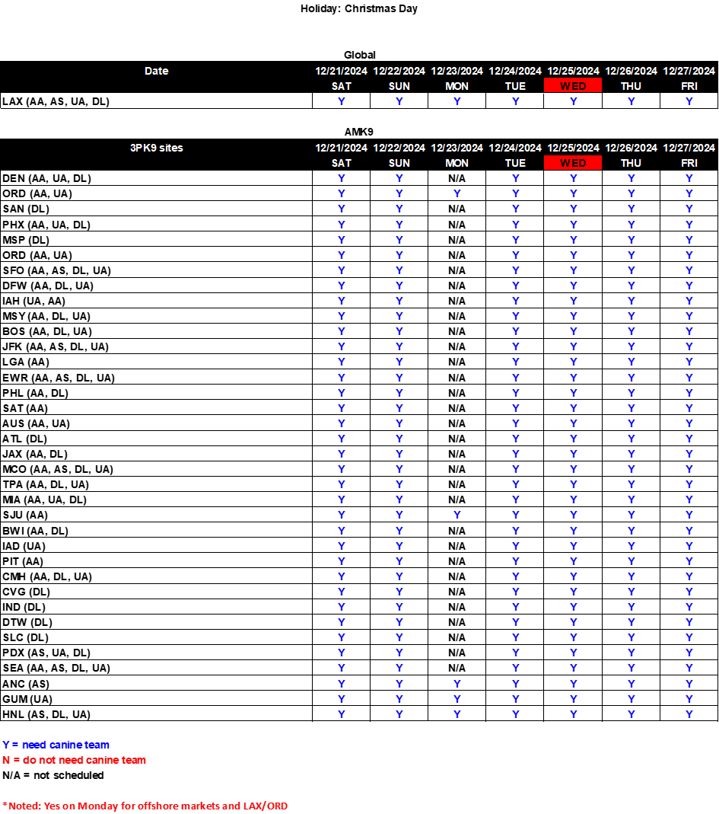

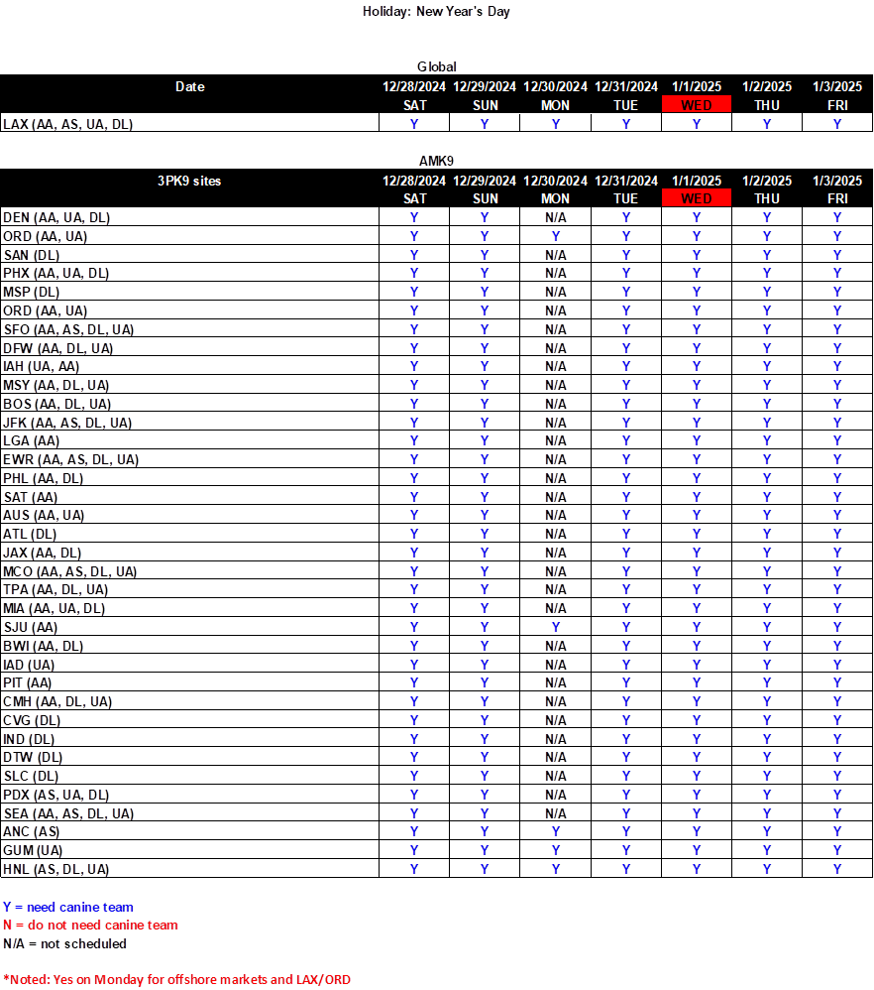

**International Transportation Plan**

|  |  |  |  |  |  |  |
| --- | --- | --- | --- | --- | --- | --- |
| ***Import/Export Plan for the ISC*** | | |  |  |  |  |
| **Holiday** | **Day of** | **Date** | **JFK** | **JFK** | **ORD** | **ORD** |
| **Week** | **Export** | **Import** | **Export** | **Import** |
| Day before | Tuesday | 12/24/2024 | YES | YES | YES | YES |
| **Christmas Day** | **Wednesday** | **12/25/2024** | **YES** | **YES** | **YES** | **YES** |
| Day after | Thursday | 12/26/2024 | YES | YES | YES | YES |
|  |  |  |  |  |  |  |
| Holiday | Day of | Date | LAX | LAX | MIA | MIA |
| Week | Export | Import | Export | Import |
| Day before | Tuesday | 12/24/2024 | YES | YES | YES | YES |
| **Christmas Day** | **Wednesday** | **12/25/2024** | **YES** | **YES** | **YES** | **YES** |
| Day after | Thursday | 12/26/2024 | YES | YES | YES | YES |
|  |  |  |  |  |  |  |
| ***Customs CBP opening plan and hours at the ISC*** | | | |  |  |  |
| **Holiday** | **Day of** | **Date** | **JFK** | **JFK** | **ORD** | **ORD** |
| **Week** | **CBP open** | **CBP hours** | **CBP open** | **CBP hours** |
| Day before | Tuesday | 12/24/2024 | YES | 24/7 | YES | 06:00 - 15:00 |
| **Christmas Day** | **Wednesday** | **12/25/2024** | **YES** | **24/7** | **NO** | **CLOSED** |
| Day after | Thursday | 12/26/2024 | YES | 24/7 | YES | 06:00 - 15:00 |
|  |  |  |  |  |  | |
| Holiday | Day of | Date | LAX | LAX | MIA | MIA |
| Week | CBP open | CBP hours | CBP open | CBP hours |
| Day before | Tuesday | 12/24/2024 | YES | 06:00 - 22:00 | YES | 06:00 - 16:00 |
| **Christmas Day** | **Wednesday** | **12/25/2024** | **NO** | **CLOSED** | **NO** | **CLOSED** |
| Day after | Thursday | 12/26/2024 | YES | 06:00 - 22:00 | YES | 06:00 -22:00 |

|  |  |  |  |  |  |  |
| --- | --- | --- | --- | --- | --- | --- |
| ***Import/Export Plan for the ISC*** | | |  |  |  |  |
| **Holiday** | **Day of** | **Date** | **JFK** | **JFK** | **ORD** | **ORD** |
| **Week** | **Export** | **Import** | **Export** | **Import** |
| Day before | Tuesday | 12/31/2024 | YES | YES | YES | YES |
| **New Year’s Day** | **Wednesday** | **1/1/2025** | **YES** | **YES** | **YES** | **YES** |
| Day after | Thursday | 1/2/2025 | YES | YES | YES | YES |
|  |  |  |  |  |  |  |
| Holiday | Day of | Date | LAX | LAX | MIA | MIA |
| Week | Export | Import | Export | Import |
| Day before | Tuesday | 12/31/2024 | YES | YES | YES | YES |
| **New Year’s Day** | **Wednesday** | **1/1/2025** | **YES** | **YES** | **YES** | **YES** |
| Day after | Thursday | 1/2/2025 | YES | YES | YES | YES |
|  |  |  |  |  |  |  |
| ***Customs CBP opening plan and hours at the ISC*** | | | |  |  |  |
| **Holiday** | **Day of** | **Date** | **JFK** | **JFK** | **ORD** | **ORD** |
| **Week** | **CBP Open** | **CBP hours** | **CBP Open** | **CBP hours** |
| Day before | Tuesday | 12/31/2024 | YES | 24/7 | YES | 06:00 - 15:00 |
| **New Year’s Day** | **Wednesday** | **1/1/2025** | **YES** | **24/7** | **NO** | **CLOSED** |
| Day after | Thursday | 1/2/2025 | YES | 24/7 | YES | 06:00 – 15:00 |
|  |  |  |  |  |  | |
| Holiday | Day of | Date | LAX | LAX | MIA | MIA |
| Week | CBP Open | CBP hours | CBP Open | CBP hours |
| Day before | Tuesday | 12/31/2024 | YES | 06:00 - 22:00 | YES | 06:00 – 16:00 |
| **New Year’s Day** | **Wednesday** | **1/1/2025** | **YES** | **06:00 - 22:00** | **NO** | **CLOSED** |
| Day after | Thursday | 1/2/2025 | YES | 06:00 - 22:00 | YES | 06:00 - 22:00 |

**Surface Transportation Network**

**CHRISTMAS STC OPERATIONS**

STCs will operate normal business hours. Transportation will run as scheduled.

STC’s will monitor National conditions to forecast need for additional transportation if necessary. Additional transportation will be secured through Freight Auction.

**NEW YEAR’S STC OPERATIONS**

STCs will operate normal business hours. Transportation will run as scheduled.

STC’s will monitor National conditions to forecast need for additional transportation if necessary. Additional transportation will be secured through Freight Auction.

**Logistics NOCC**

* 24-hour coverage, including on the holiday, to provide assistance and escalation
* Increased monitoring of TDNA, TSND, Yard Cycle Time and WTIL

Please disseminate these policies and procedures to the appropriate personnel in your area. Your immediate attention to these details and dispatch procedures is appreciated. Thank you for your assistance.

cc: Joshua D. Colin, Ph.D.

Isaac S. Cronkhite